"Portrait of a Persian Lady", Folio from the Davis Album
Unknown | Dated 1149 AH/1736–37 CE | Record IMG-WA0007

1. Original Image
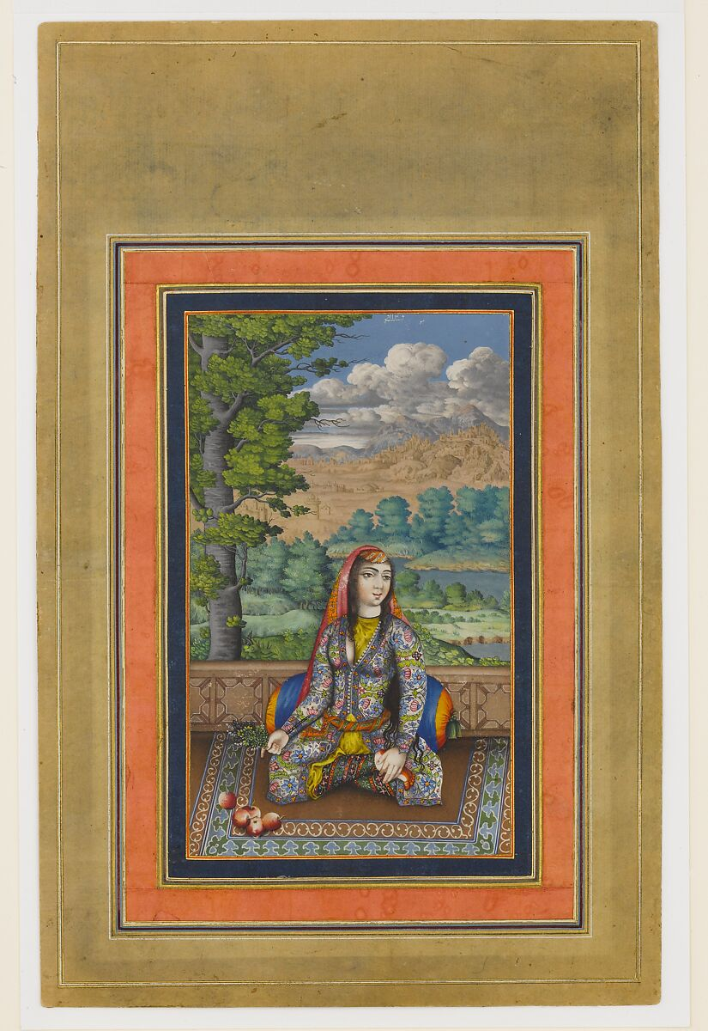
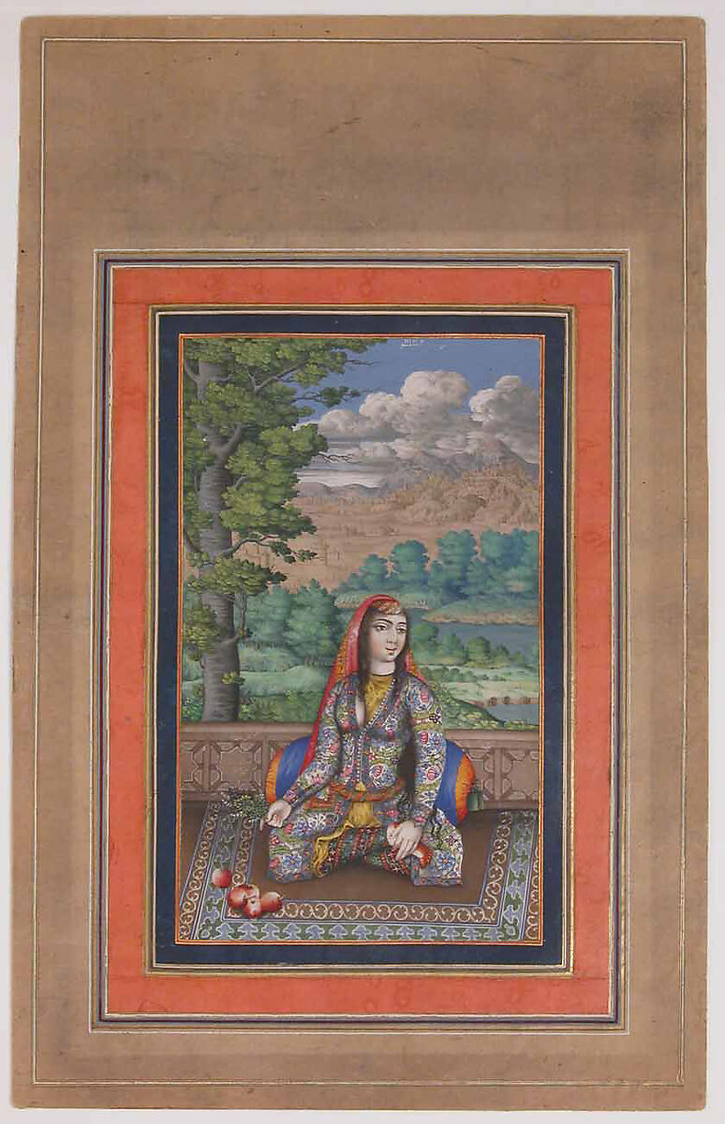
IMG-WA0006. "Portrait of a Persian Lady", Folio from the Davis Album, dated 1149 AH/1736–37 CE, Attributed to Iran, Isfahan, Ink, opaque watercolor, and gold on paper, Page: H. 13 1/8 in. (33.3 cm), W. 8 1/4in. (21cm), Mat: H. 19 in. (48.3 cm), W. 14 1/4 in. (36.2 cm). The Metropolitan Museum of Art.
2. Record Summary
Record ID | IMG-WA0007
Original title | “Portrait of a Persian Lady,” Folio from the Davis Album
English title | “Portrait of a Persian Lady,” Folio from the Davis Album
Alternative title | N/A
Creator | Unknown
Creation date | Dated 1149 AH/1736–37 CE
Country | Iran
Cultural region | West Asia; attributed to Isfahan
Historical period | Afsharid period
Image type | Manuscript painting or album folio
Medium | Ink, opaque watercolour and gold on paper
Dimensions | Page: 33.3 × 21 cm; mat: 48.3 × 36.2 cm
Primary subject | Seated woman on a balcony
Secondary subjects | Landscape, tree, water, mountains, fruit, textiles and borders
Source institution | The Metropolitan Museum of Art
Collection or object number (optional) | 30.95.174.32

3. Image Description

3.1 Short Description
A richly dressed seated woman appears within a rectangular painting surrounded by coloured and gold borders. She sits cross-legged on a patterned surface with fruit near one hand. Behind her, a tree, river, vegetation, mountains and large clouds form an expansive landscape.

3.2 Detailed Visual Description
The woman wears a long garment decorated with blue, red, white and gold floral motifs and a red head covering. One hand rests near a group of fruit, while the other rests on her knee. A low railing separates the foreground balcony from the landscape.
A large tree rises at the left. Blue-green trees, water, plains and rocky mountains recede into the distance. White-grey clouds occupy a blue sky. Nested red, blue and gold borders surround the painting. A small white inscription or date is visible in the sky but cannot be read at this scale.

4. Formal Features
Field | Analysis
Composition | Centred seated figure enclosed by borders and backed by a landscape.
Viewpoint or camera angle | Slightly elevated frontal view.
Shot scale | Full seated figure.
Spatial depth | Foreground figure and railing, followed by water, plains and mountains.
Lighting | Modelled face and hands with evenly illuminated landscape.
Colour palette | Gold, red, blue, turquoise, green, tan and white.
Contrast | Saturated clothing against a softer landscape.
Visual focus | Seated figure.
Texture | Floral textiles, foliage, clouds and gold borders.
Movement or stillness | Still figure with gentle movement in branches and clouds.
Medium-specific features | Opaque watercolour, ink outlines, gold and album-page framing.

5. Historical Context and Purpose

5.1 Historical Context
The Met dates the folio through a small inscription read as 1149 AH/1736–37 CE and attributes its production to Isfahan. The Museum notes the use of European-derived modelling, shading and perspective in the figure and landscape. These devices had been selectively incorporated into Iranian court painting before the eighteenth century. The artist and sitter remain unidentified. [IMG-WA0007-S01] Image Purpose and Circulation

5.2 Image Purpose and Circulation
Probable purpose: Elite artistic production for inclusion within an album.
Current institutional use: Display and study within The Met’s Islamic Art collection.

